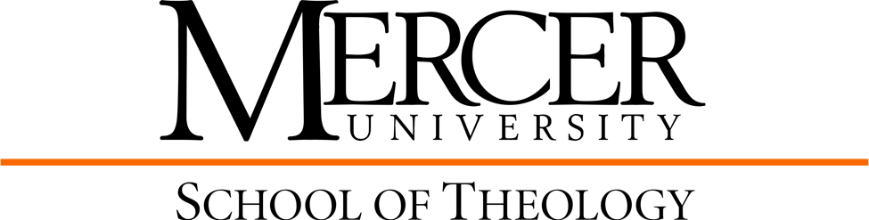

Master of Theological Studies Curriculum Template
Thesis Option
2026-2027
Core Courses: 24 hours
Philosophy for Theological Thought | THTP 501 |  | 3
Foundations in Old Testament | THOT 500 |  | 3
Foundations in New Testament | THNT 500 |  | 3
Foundations in Church History | THCH 500 |  | 3
Foundations in Theology | THTP 500 |  | 3
(Prerequisite: THCH 500 recommended)  Ethics | THET 500 |  | 3
(Prerequisites: THCH 500; THTP prerequisite or concurrent)  Research Methodology | THEO 713 |  | 2
Thesis Writing 1 | THEO 714 |  | 2
Thesis Writing 2 | THEO 715 |  | 2
Courses in Concentration: 24 hours
(see below for specific requirements)
Cultural Context Elective: |  |  | 3
 |  |  | 3
 |  |  | 3
 |  |  | 3
 |  |  | 3
 |  |  | 3
 |  |  | 3
 |  |  | 3
Total Hours for M.T.S: 48
Biblical Studies Specialization: 24 Hours
Biblical Languages 12 hours
Directed Electives (at least one course must be a cultural context elective) 12 hours
Total Hours for MTS: 48
Church Music Specialization: 24 Hours
THPT 507 The Theology & Art of Gathering God’s People 3 hours
Directed Elective from Theology (must be a cultural context elective) 3 hours
*Directed Electives from the School of Music 18 hours
Total Hours for MTS: 48
*See the MTS/MSM combined degree

Ethics Specialization: 24 Hours
Directed Electives (at least one course must be a cultural context elective) 24 hours
Total Hours for MTS: 48
Historical/Theological Specialization: 24 Hours
Directed Electives (at least one course must be a cultural context elective) 24 hours
Total Hours for MTS: 48
Practical Theology Specialization: 24 Hours
THPT 502 Emotional Intelligence in Ministry & Leadership 3 hours
THSP xxx Elective in Spirituality 3 hours
Directed Electives (at least one course must be a cultural context elective) 18 hours
Total Hours for MTS: 48

