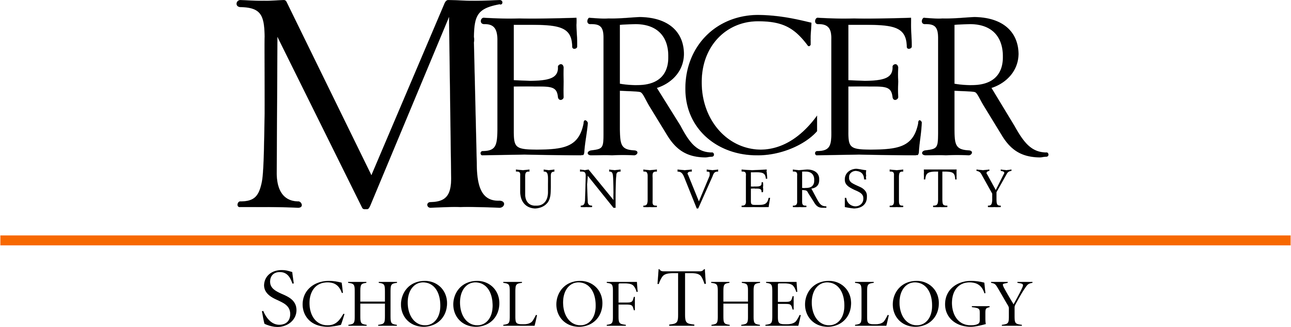

M.Div./M.S. Organizational Leadership,
Concentration in Leadership for the Nonprofit Organization Curriculum Template
2025-2026

Religious Heritage: 27 hours
Hebrew Exegesis 1 & Hebrew Exegesis 2 THBL __________ 3 __________
Or THBL __________ 3 __________
Greek Exegesis 1 & Greek Exegesis 2
Foundations in Old Testament THOT 500 3 __________
Elective in Old Testament THOT __________ 3 __________
Foundations in New Testament THNT 500 3 __________
Elective in New Testament THNT __________ 3 __________
Foundations in Church History THCH 500 3 __________
Foundations in Theology THTP 500 3 __________
Elective in Theology/Philosophy THTP __________ 3 __________

Personal, Communal, & Spiritual Formation: 15 hours
Spiritual Formation 1 & 2 THSP 511 1 __________
THSP 512 1 __________
Vocational Formation 1 & 2 THPT 511 1 __________
THPT 512 1 __________
Ministerial Integration 1 & 2 THPT 513 1 __________
THPT 514 1 __________
Elective in Spirituality THSP __________ 3 __________
Emotional Intelligence in Ministry & Leadership THPT 502 3 __________
Ethics THET 500 3 __________
Cultural Context: 9 hours
Global Perspectives in Ministry & Mission THPT 500 3 __________
Elective in Comparative Religions __________ 3 __________
Cultural Context Elective __________ 3 __________

Ministerial & Public Leadership: 12 hours
What You Do is a Sacred Calling: Nurturing Faith in Ministry THPT 505 3 __________
Preaching THPT 506 3 __________
Change & Conflict THPT 680 3 __________

*Choose 3 hours from the following Ministry Courses: THPT __________ 3 __________

THPT 503 Spiritual Care through Crisis Ministry
THPT 507 The Theology & Art of Gathering God’s People
THPT 608 Mission Methodology & Practice
THPT 647 Trauma Stewardship
THPT 650 Spiritual Direction

THPT 652 Gender & Sexuality
THPT 654 Death & Dying
THPT 800 Proctor Conference
*or other THPT ministry course(s)

Practicum/Internship: 6 hours
Leadership in Context THPT 701 3 __________
Leadership & Polity in the Church THPT 702 3 __________

Electives: 9 hours from CoPA
**Elective in area of specialization 3 See below
**Elective in area of specialization 3 See below
**Elective in area of specialization 3 See below

Master of Science in Organizational Leadership: 30 hours
*Introduction to the Nonprofit Sector (as Theology elective) NONP 600 3 __________
*Nonprofit Governance and Volunteer Administration (as Theology elective) NONP 601 3 __________
*Budgeting for the Nonprofit Sector (as Theology elective) NONP 700 3 __________
Capstone Seminar in Leadership in the Nonprofit Organization NONP 701 3 __________
**Ethics (in place of LEAD 601 Ethical Challenges in Organization) THET 500 3 *see above
Leading in Global Organizations: Gender and Generations LEAD 604 3 __________
Research Methods for Leaders LEAD 605 3 __________
Research Strategies for Leaders LEAD 705 3 __________
**Change & Conflict THPT 680 3 *see above
(in place of LEAD 602 Organizational Theory and Behavior)
**Leadership in Context THPT 701 3 *see above
(in place of LEAD 600 Strategic Leadership)

Note: Students may substitute (with prior approval from both faculty advisors) one to three of the courses listed below for NONP 601 and/or NONP 700 if students will benefit from the substitution. Each course is 3 credit hours.
- ORGD 600 – Introduction to Organizational Development
- ORGD 601 – Organizational Consulting & Leadership Coaching
- ORGD 700 – Building Organizational Culture
- ORGD 701 – Capstone Seminar in Leadership for Organizational Development
- HCAL 600 – Introduction to Health Care Systems
- HCAL 601 – Healthcare Leadership
- HCAL 602 – Healthcare Systems Budgeting for the Nonfinancial Leader
- HCAL 700 – Health Care Policy and Law
- HCAL 702 – Capstone Seminar in Leadership for Healthcare Professional
- LEAD 701 – Special Topics in Organizational Leadership
- PSLD 604 –Conflict Resolution and Negotiations

M.Div. Courses: 69 hours
M.S. Courses: 21 hours
Total M.Div./M.S.: 90 hours

*The M.Div./M.S. combined degree requires a minimum of 90 semester hours of graduate credit. In order to meet degree requirements for the M.Div., the student must complete a minimum of 78 hours (69 core hours of study in Theology and 9 hours electives from CoPA). In order to meet degree requirements for the M.S., the student must complete a minimum number of 30 hours (21 core hours from CoPA and 9 hours from Theology).

