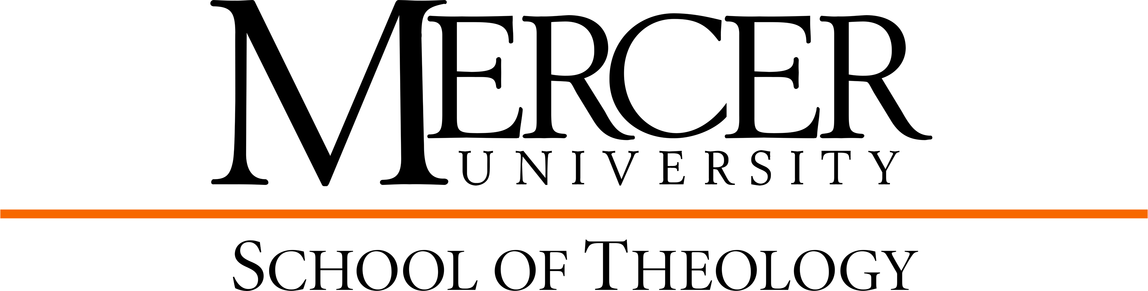

M.Div./M.S. Clinical Mental Health Counseling Curriculum Template
2025-2026

Religious Heritage: 27 hours
Hebrew Exegesis 1 & Hebrew Exegesis 2 THBL __________ 3 __________
Or THBL __________ 3 __________
Greek Exegesis 1 & Greek Exegesis 2
Foundations in Old Testament THOT 500 3 __________
Elective in Old Testament THOT __________ 3 __________
Foundations in New Testament THNT 500 3 __________
Elective in New Testament THNT __________ 3 __________
Foundations in Church History THCH 500 3 __________
Foundations in Theology THTP 500 3 __________
Elective in Theology/Philosophy THTP __________ 3 __________

Personal, Communal, & Spiritual Formation: 15 hours
Spiritual Formation 1 & 2 THSP 511 1 __________
THSP 512 1 __________
Vocational Formation 1 & 2 THPT 511 1 __________
THPT 512 1 __________
Ministerial Integration 1 & 2 THPT 513 1 __________
THPT 514 1 __________
Elective in Spirituality THSP __________ 3 __________
Emotional Intelligence in Ministry & Leadership THPT 502 3 __________
Ethics THET 500 3 __________
Cultural Context: 9 hours
Global Perspectives in Ministry & Mission THPT 500 3 __________
Elective in Comparative Religions __________ 3 __________
*Social and Cultural Issues in Counseling COUN 613 * see below

Ministerial & Public Leadership: 12 hours
What You Do is a Sacred Calling: Nurturing Faith in Ministry THPT 505 3 __________
Preaching THPT 506 3 __________
*Internship in Clinical Mental Health Counseling I COUN 610 * see below
*Internship in Clinical Mental Health Counseling II COUN 636 * see below
Practicum/Internship: 6 hours
Clinical Pastoral Education Unit 1 THPT 703 6 __________

Electives: 6 hours (Spiritual Care courses)
___________________________________________ ________________ 3 __________
___________________________________________ ________________ 3 __________
___________________________________________ ________________ * see below

Clinical Mental Health Counseling Core: 54 hours
Career Development COUN 601 3 __________
Introduction to Clinical Mental Health Counseling COUN 602 3 __________
Psychopathology and Diagnosis COUN 604 3 __________
Group Counseling and Group Work COUN 605 4 __________
Counseling Skills and Techniques COUN 606 3 __________
Addictions Counseling COUN 608 3 __________
Practicum COUN 609 3 __________
Internship in Clinical Mental Health Counseling I COUN 610 3 __________
Counseling Theory COUN 612 3 __________
Social and Cultural Issues in Counseling COUN 613 3 __________
Human Growth and Development COUN 614 3 __________
Assessment and Testing COUN 617 3 __________
Ethics & Professional Issues COUN 618 3 __________
Research and Program Evaluation COUN 621 3 __________
Professional Seminar COUN 630 1 __________
Orientation to Professional Practice COUN 635 1 __________
Internship in Clinical Mental Health Counseling II COUN 636 3 __________
Theories of Family Counseling COUN 641 3 __________
Crisis, Trauma, & Grief Counseling COUN 645 3 __________

M.Div. Courses: 66 hours
M.S. Courses: 54 hours
Total M.Div../M.S.: 120 hours
*The M.Div./M.S. in Clinical Mental Health Counseling degree requires a minimum of 120 semester hours of graduate credit. It may be completed within four years with a maximum of thirteen (13) credit hours per semester (Fall/Spring) and six (6) credit hours each summer. In order to meet degree requirements for the M.Div., the student must complete a minimum of 78 hours (60 core hours of study in Theology, 6 elective hours in Spiritual Care from Theology, and 12 hours from the Counseling core). In order to meet degree requirements for the M.S., the student must complete a minimum number of 60 hours (54 core hours of study in Counseling and 6 hours from Theology as elective credit).

Graduation Requirements:
Minimum 3.0 GPA in Counseling classes and 2.5 GPA in M.Div. classes, completion of course requirements and 120 hours, completion of CPE unit, completion of three semesters of clinical practice that totals 700 hours of clinical experience, achieving a passing score on the Counselor Preparation Comprehensive Examination (CPCE).

