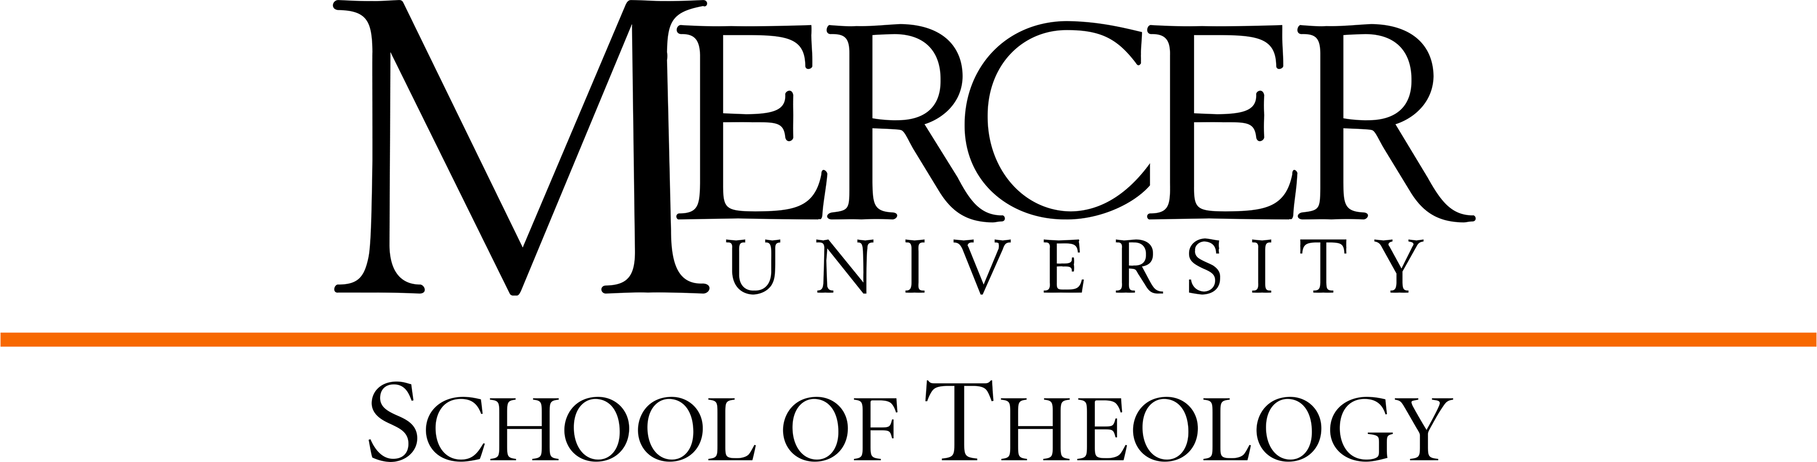

M.A.C.M./M.S. Organizational Leadership,
Concentration in Leadership for the Nonprofit Organization Curriculum Template
2025-2026

Theology Core: 32 hours

Biblical Studies: 6 hours
Foundations in Old Testament THOT 500 3 __________
Foundations in New Testament THNT 500 3 __________

Historical & Theological Studies: 6 hours
Foundations in Church History THCH 500 3 __________
Foundations in Theology THTP 500 3 __________

Global & Cultural Studies: 6 hours
Global Perspectives in Ministry & Mission THPT 500 3 __________
Cultural Context Elective __________ 3 __________

Moral & Spiritual Formation Studies: 5 hours
Spiritual Formation 1 THSP 511 1 __________
Spiritual Formation 2 THSP 512 1 __________
Ethics THET 500 3 __________

Ministerial & Public Leadership: 6 hours
Leadership in Context THPT 701 3 __________
Leadership in the Church THPT 702 3 __________

Specialization: 9 hours
*Elective in area of specialization 3
*Elective in area of specialization *see below
*Elective in area of specialization *see below

Master of Science in Organizational Leadership Courses: 30 hours
*Introduction to the Nonprofit Sector NONP 600 3 __________
(as Theology Elective in area of specialization)
*Nonprofit Governance and Volunteer Administration NONP 601 3 __________
(as Theology Elective in area of specialization)
Budgeting for the Nonprofit Sector NONP 700 3 __________
Capstone Seminar in Leadership in the Nonprofit Organization NONP 701 3 __________
Strategic Leadership LEAD 600 3 __________
Ethical Challenges in Organization LEAD 601 3 __________
Organizational Theory and Behavior LEAD 602 3 __________
Leading in Global Organizations: Gender and Generations LEAD 604 3 __________
Research Methods for Leaders LEAD 605 3 __________
Research Strategies for Leaders LEAD 705 3 __________

Note: Students may substitute (with prior approval from both faculty advisors) one to three of the courses listed below for NONP 601 and/or NONP 700 if students will benefit from the substitution.

Introduction to Organizational Development ORGD 600 3
Organizational Consulting & Leadership Coaching ORGD 601 3
Building Organizational Culture ORGD 700 3
Capstone Seminar in Leadership for Organizational Development ORGD 701 3
Introduction to Healthcare Systems HCAL 600 3
Healthcare Leadership HCAL 601 3
Health Care Policy and Law HCAL 700 3
Healthcare Systems Budgeting for the Nonfinancial Leader HCAL 701 3
Special Topics in Organizational Leadership LEAD 701 3
Conflict and Negotiations PLSD 604 3

M.A.C.M. Courses: 32 hours
M.S. Courses: 30 hours
Total M.A.C.M./M.S.: 62 hours

**The M.A.C.M./M.S. combined degree requires 62 semester hours of graduate credit. In order to meet degree requirements for the M.A.C.M.., the student must complete a minimum of 38 hours (32 core hours of study in Theology and 6 hours electives from CoPA). In order to meet degree requirements for the M.S., the student must complete a minimum number of 30 hours.

Graduation Requirements:
Minimum 3.0 GPA in Penfield classes and 2.5 GPA in Theology classes and completion of all course requirements and 62 hours within maximum timeframe of six years.

